M02 Technical Web Developer Documentation

You will submit this with your guided exploration. See M02L04_HTML_Structure_Website on how to write technical developer documentation.

Use headings to organize topics and create a table of contents to be able to quickly access information. Here is how to add headings and subheadings:
- Headings, Subheadings, and Table of Contents (Google Docs)
- Headings, Subheadings, and Table of Contents (Microsoft Word)

As you add new headings to organize your documentation, refresh the table of contents below.

Web Development Tools and Resources
Development Environment
Version Control
Web Development Concepts
Web Development Resources
HTML
Overview of HTML
HTML Attributes
HTML Comments
Lists
CSS Basics
Bootstrap
Web Accessibility and Inclusive Design

Web Development Tools and Resources
Keep resources that are valuable enough that you would want to find them again later on Version Control and Integrated Development Environment (IDE)
Add resources in the table below that help you with
- Git
- Github
- VSCode or VSCodium
Resource / Link | Description - What is it used for?

Development Environment
Document information that would help you set up and use your programming environment again. Include only information that is useful as a future reference.
[Begin your documentation here. Add and organize subheadings as needed.]

Version Control
Document the tools, terminology, and workflow you need to version, back up, and manage your work.
[Begin your documentation here. Add and organize subheadings as needed.]

Web Development Concepts
Building a website using HTML, CSS with Bootstap

Web Development Resources
Keep resources that are valuable enough that you would want to find them again later on Version Control and Integrated Development Environment (IDE)
Add resources in the table below that help you with
- HTML
- CSS and Bootstrap

Resource / Link | Description - What is it used for?
M02_Web_Development_Inclusive_Design | Class resources for module 2

HTML

Overview of HTML
HTML provides structure for a web page using elements. Most elements have a start and end tag.
Here is an example of the heading 1 element
<h1>My Top Heading</h1>
<h1> is the start tag
</h1> is the closing tag
My Top Heading is the content to be displayed as a heading on the webpage

Introduction to HTML explains the structure of a web page and HTML elements.

Here is the basic structure of a web page. The content visible on a web page goes in the body.
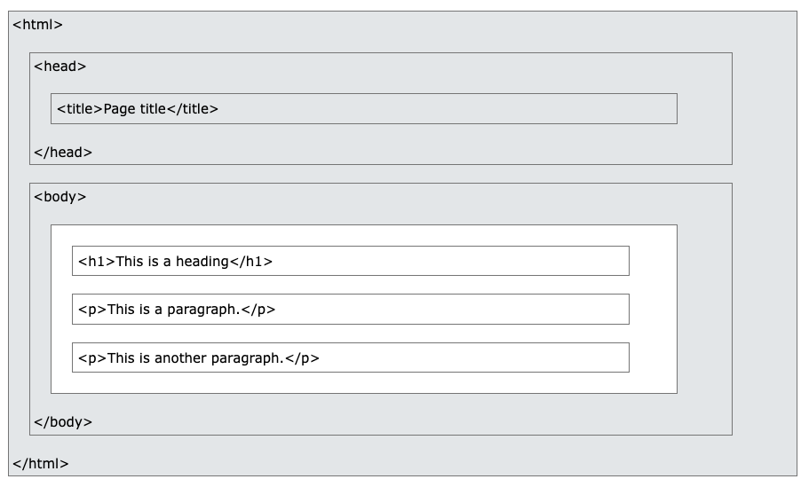

Example of an HTML web page created using My First Heading
<!DOCTYPE html>
<html>
<body>

<h1>Colorado Water Restrictions</h1>
<p>As of 08/26/2026 Denver has stated no spray irrigation after Sept. 30th 2026. Below is a link to Denver water restrictions.</p>
<p><a href="https://www.denverwater.org/residential/rebates-and-conservation-tips/summer-watering-rules">Current watering guidelines and restrictions</a></p>
<h2> How did Denver water make this decision?</h2>
<p> Because of record low snow pack for the 2025-2026 snow season, record low rain fall throughout the summer, and customers failing to conserve enough water Denver has made the hard decision to end the current watering season early. This restriction is effect until Denver Water votes to end it. From early reports Denver water will not vote again until the spring of 2027.</p>
<!-- Check for updated restrictions monthly. Denver has stated that the restriction is indefinite until voted on in the future.-->
<img src="https://yardandgarden.extension.iastate.edu/files/2025-06/Watering%20ban%20by%20west%20AdobeStock_371887035%20%281%29.jpg"/img>
</body>
</html>

Html Element Example | Description
<html> | States what type of document it is. It is located on the top and the bottom of the page
<p> </p>  <p>As of 08/26/2026 Denver has stated no spray irrigation after Sept. 30th 2026. Below is a link to Denver water restrictions.</p> | Is the symbol for the start and ending of a paragraph
<a /a>  <p><a href="https://www.denverwater.org/residential/rebates-and-conservation-tips/summer-watering-rules">Current watering guidelines and restrictions</a></p> | This represents adding a link
<h1 /h1>  <h1>Colorado Water Restrictions</h1> | Is a header for the page

HTML Attributes
HTML attributes provide more info for HTML elements.

Html Element | Description
Href=” | Is added before the url
Img=” | Is how to add an image

HTML Comments
Are for me and others to know whats going on within the HTML page

LISTS
Allows users to list related groups together either ordered or unordered

CSS Basics
Add heading 3 to organize information

Bootstrap
Add heading 3 to organize information

Web Accessibility and Inclusive Design
Add heading 3 to organize information

